40.21: 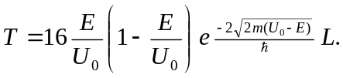
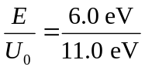and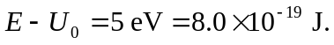
a) 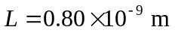
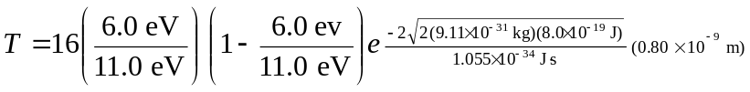
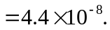
b) 